**Analysis and Visualisation**

By Ankit Narang

**Introduction**

This article is about the visualisation and insights we got after analysing the data from the twitter account called WeRateDogs, who posts pictures and videos related to dogs and rate them.

Before analysing and visualizing the data, it has been thoroughly assessed and cleaned in order to remove misinterpretation in the charts and graphs.

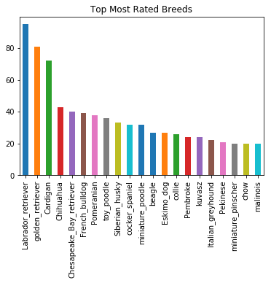Once I had cleaned the data, I was very interested in knowing which breeds of dogs were most rated by them as from it we can get an idea about which dogs people prefer. According to the Bar chart shown below, I found out that Labrador retriever was the most rated breed followed by Golden retriever and Cardigan.

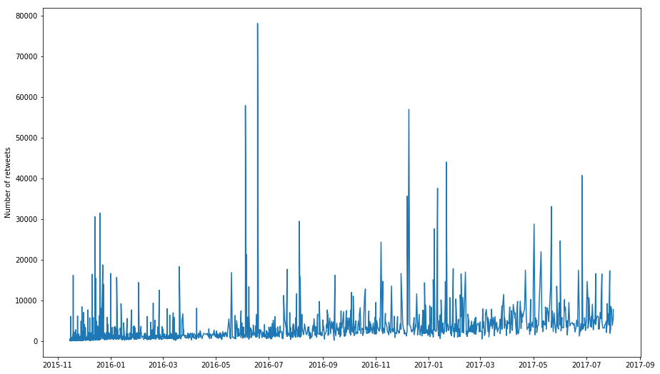As we had the retweets data, I tried to find out the trend of the number of retweets over time for WeRateDogs twitter account and I saw a gradual increase in the number of retweets over the years with sudden increase in between as shown below.

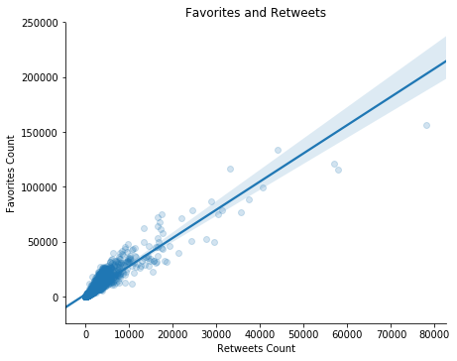Then I explored the relationship between favorites and retweets and found that there is a positive relation between both. From the figure below we can get an idea that as the number of retweets increase the engagement of the post also increases and it further leads to the increase in the number favorites.

At last I plotted a line chart to find out the monthly number of tweets over time and found that along with time the number of tweets for the account are decreasing. However, this does not mean that the channel is becoming inactive as we saw that the number of retweets are increasing which means the more and more people are engaging with the account.

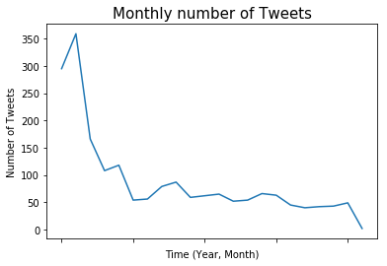

**Conclusion**

While working on this project, I came across many interesting facts about tweets, retweets and of course WeRateDogs account. I was able to get involved with the complete process of data wrangling and made some insights out of the cleaned data and plot the relationship of many variables.

Thank you